G V Ishara Harshana

IIT ID: 20244040

UoW ID: w2121271

COURSEWORK

SOFTWARE DEVELOPMENT 1

**Input Validation**

1. If user enters a string as date input, gives a message to enter an integer.



1. If a user enters an inappropriate value, it gives a message as necessary.

(Day value range: 1 – 31, Month value range: 1 – 12, Year value range: 2000-2024)

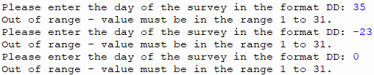

1. If a user enters a single digit instead of double digits, the application automatically converts it into a double digit’s value and continues to the next step.



1. If there is no csv file related to the requested date, give a message and ask the user whether to continue or not.

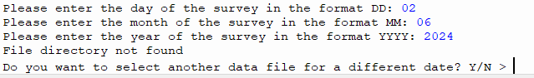

1. Until the user enters the right input, the program asks for the right input.   
     
   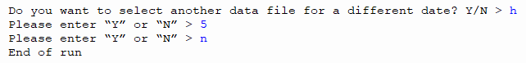

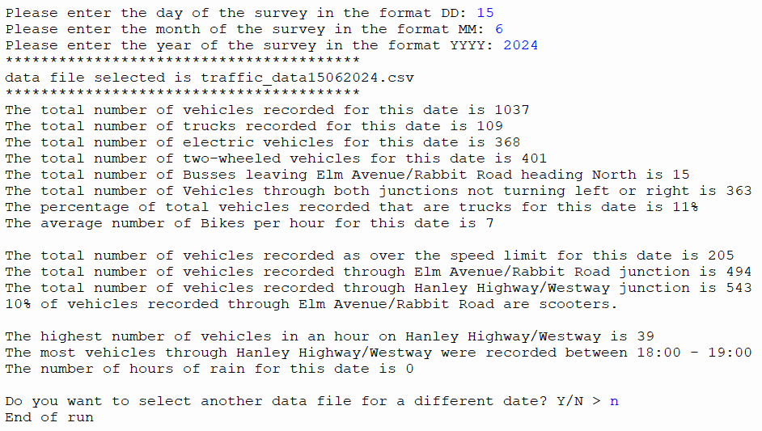**Sample Input and Output**